

**National Institute of Technology, Calicut**

**Department of Electronics and Communication Engineering**

**EC3093D - Digital Signal Processing Lab**

Experiment – 4 : FFT and Z - Transform

Submitted by : Group A-03

Group Members

Adwayith K S B210664EC

Adhyuth Narayan B210650EC

Aditya Tuppad B210038EC

1. FFT: Implement the radix-2 FFT algorithm to compute the N-point DFT 𝑋[𝑘] of a sequence 𝑥[𝑛] of length 𝑁. Assume 𝑁 = 2𝑚. Make ‘𝑁’ a variable. Modify to compute the 𝑁 -point IDFT 𝑥[𝑛] of 𝑋[𝑘].

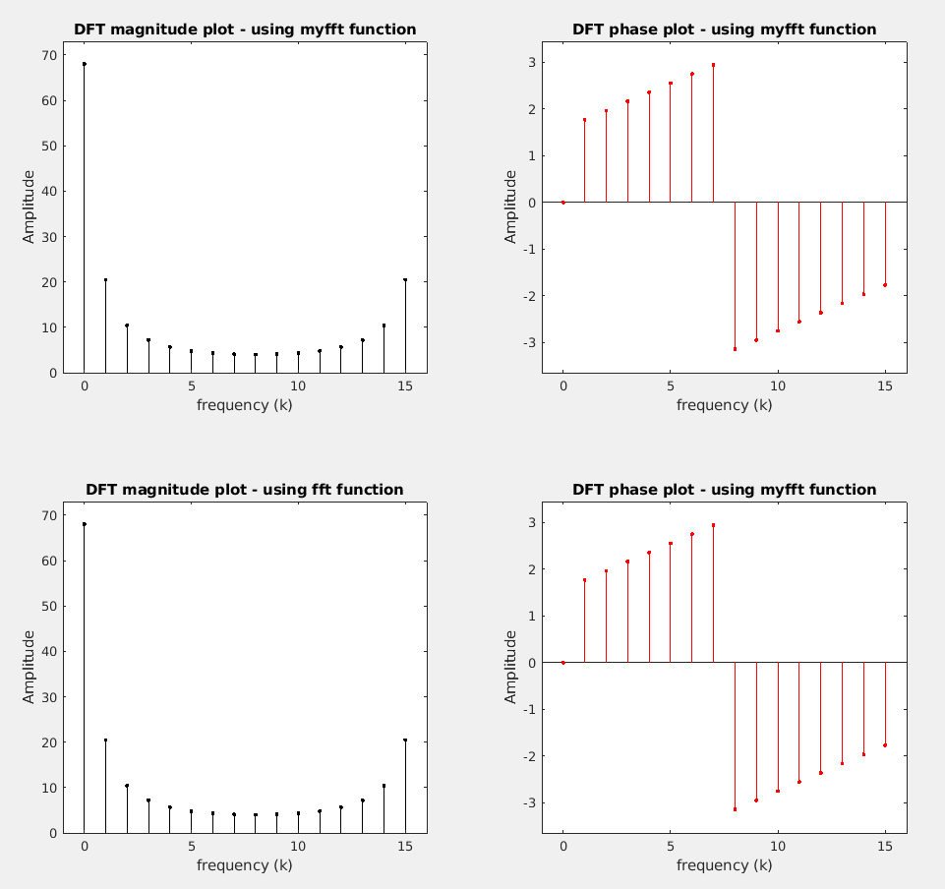

* In this question we used an input signal of $x = \frac{n}{2}.\cos\left(2π n\right) + j\sin\left(2π n\right)$ and then found out its FFT using myfft (our self-defined function) and the inbuilt fft function of MATLAB.
* We can see that the output in both case matches exactly.

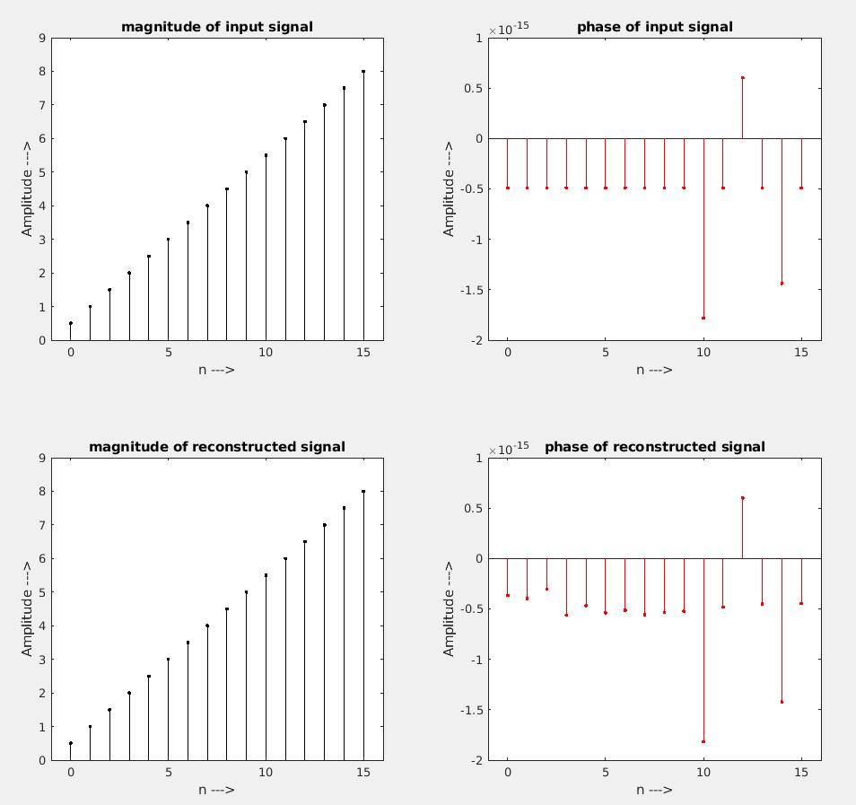

* As the continuation of the question, we were asked to find out the N-point IDFT also.
* So, we gave the existing FFT that we calculated using myfft function to the user-defined myifft function to find out the N-point IDFT.
* As we can see the input signal and the reconstructed signal matches exactly.

1. Test the FFT program in (1) by computing DFT for
2. A rectangular signal
3. sinusoidal signal
4. Unit impulse

Try to reconstruct the signals back from the spectrum using your IDFT program. Observe the effect of zero padding using different number of samples, while plotting the spectrum.

a)

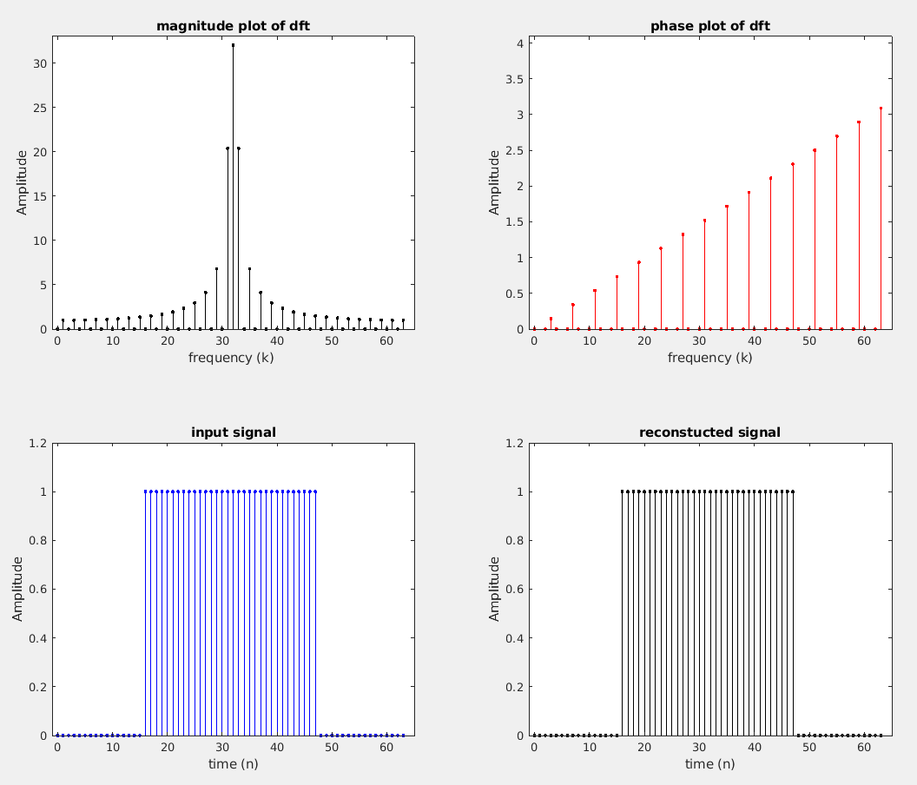

* Here the input is a rectangular signal and its DFT plot is a sinc function, the input was also reconstructed properly.
* The DFT of a rectangular signal is given as $X\left(k\right) = \text{sinc}\left(\frac{k - \frac{N}{2}}{\frac{N}{2}}\right)$)

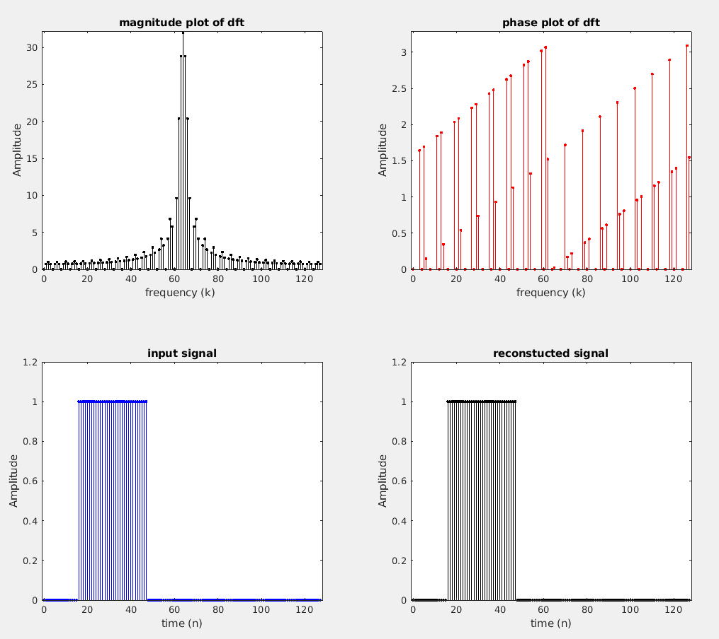

* Here we have zero padded the above signal and we can observe that by zero-padding the details in the DFT plot has increased, the resolution of the DFT plot has increased significantly especially in the magnitude plot.

b)

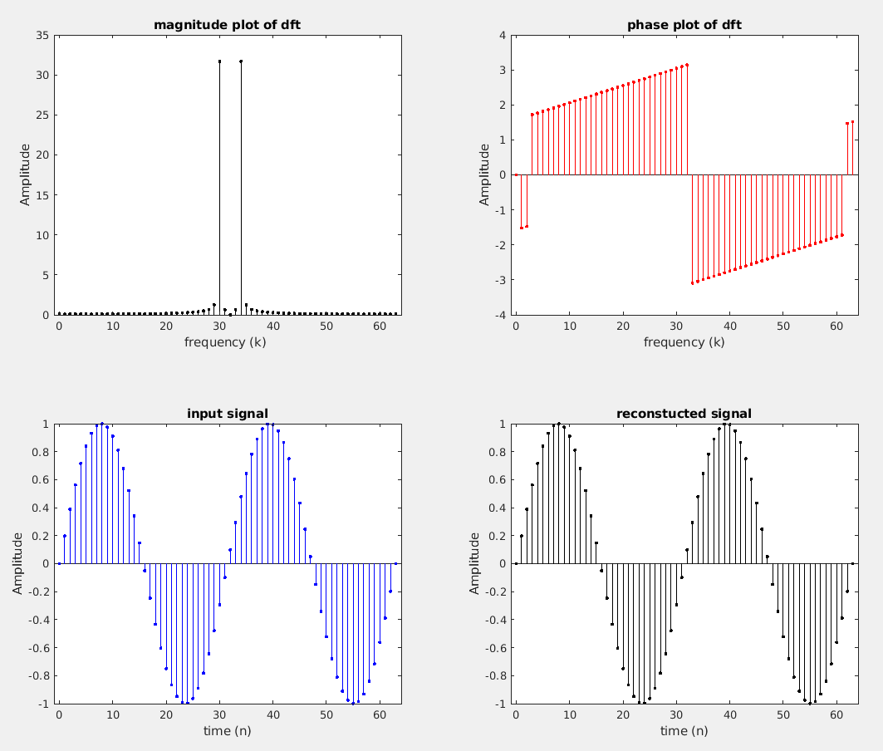

* Here the input signal is a sine wave and the DFT plot that we obtained is clearly two spikes at a positive and negative frequency respectively, therefore the plotted DFT plot matches with our expected results.
* When we tried to reconstruct the signal from DFT plot using myifft function which had defined earlier, we can see that the reconstructed signal matches exactly with the input sine wave.
* The equation for the DFT of a sine wave is $X\left(k\right)=j . \left[δ\left(k-k_{0}\right)-δ\left(k+k_{0}\right)\right]$

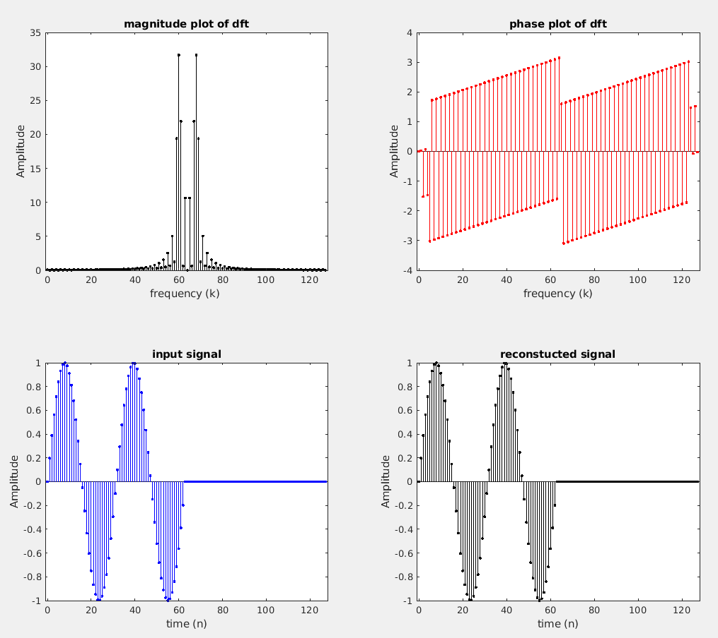

* On zero padding the input sine wave we can see that the resolution in the frequency domain has increased.
* And zero padding also provides improved Interpolation accuracy in the frequency domain especially when the true frequency doesn’t align with the frequency bin.

c)

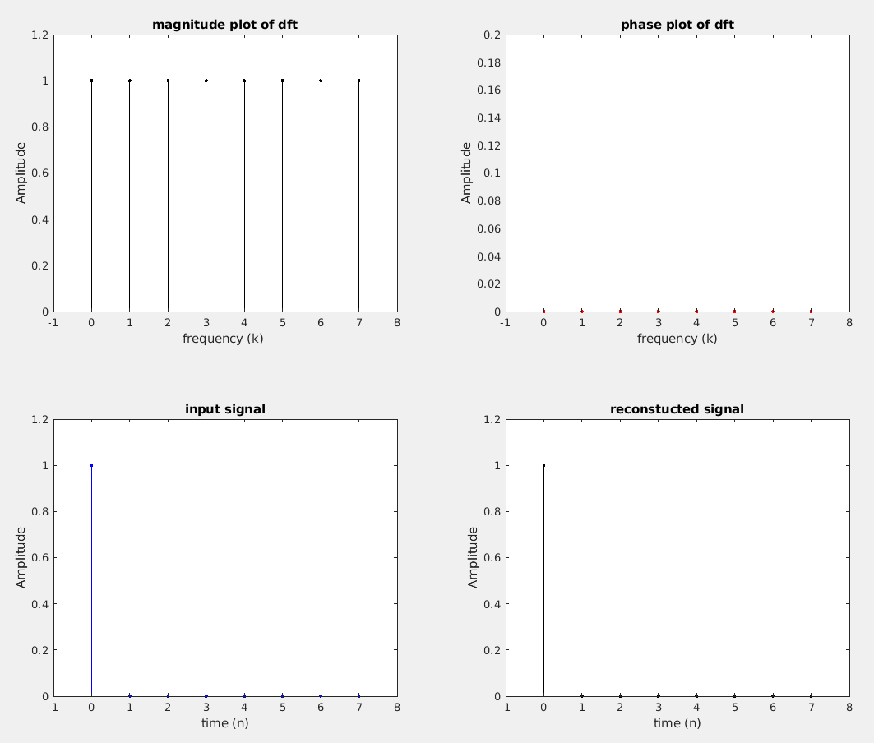

* Here we have plotted the DFT of impulse signal, we can observe that the DFT is a one at all values of k.
* The DFT of impulse signal is given as :

$X\left(k\right)=\sum_{n=0}^{N-1}{δ\left[n\right]}⋅e^{-j\frac{2π}{N}kn} = e^{-j\frac{2π}{N}k.0} = 1$

* Therefore, the above theoretical equation matches with the output plot.
* We can also see that the reconstructed signal is exactly similar to the input signal.

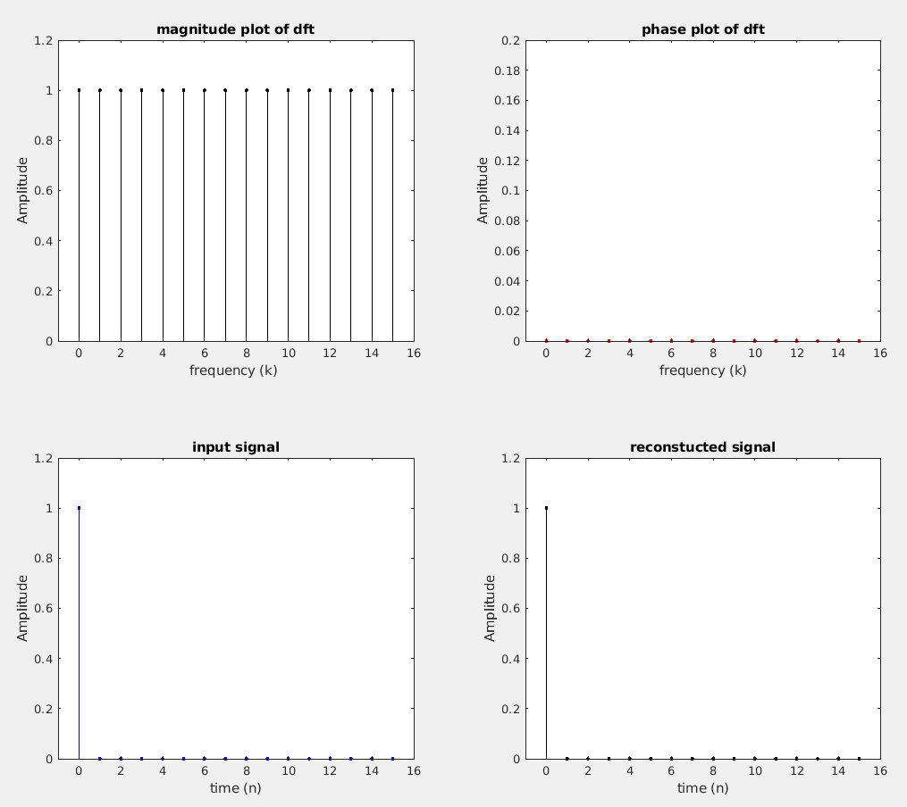

* After zero padding we can see that the number of signal points have increased in the frequency domain and hence the overall signal resolution has increased due to zero padding.

1. Fast linear convolution using FFT :
2. Use audioread, read the sample audio waveform acoustic.wav and the impulse response of a cathederal impulse_cathederal.wav (the impulse response models the reverberation that you typically observe in a cathederal). Perform convolution (Use the code you have written in Experiment 1!) between the audio signal and the impulse response. Find the time required to perform the convolution.
3. Another approach to do convolution is by using FFT as follows.

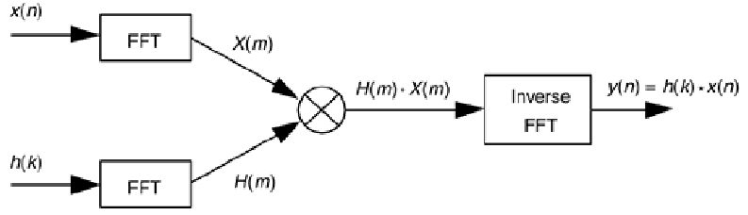

Note here that the input 𝑥[𝑛] and ℎ[𝑛] should be appropriately zero-padded (as done in Experiment 3). Find the time required to perform convolution using this approach, using the FFT code that you have written. Is there any difference, in the time required to perform convolution, between the FFT approach and using straightforward convolution?

What are your inferences?

1. Real time implementation: Audio signals are typically quite long (though in our example, this is not the case). Hence, for real time implementation, processing should happen in segments. Two such approaches are: Overlap-add and Overlap-save. Implement either overlap-add or overlap-save method for performing convolution. Modify the algorithm to use the FFT based filtering as in (b) to perform convolution. Compare the execution time for the different approaches as a function of block size (a parameter in overlap-add/overlap-save method).

a)

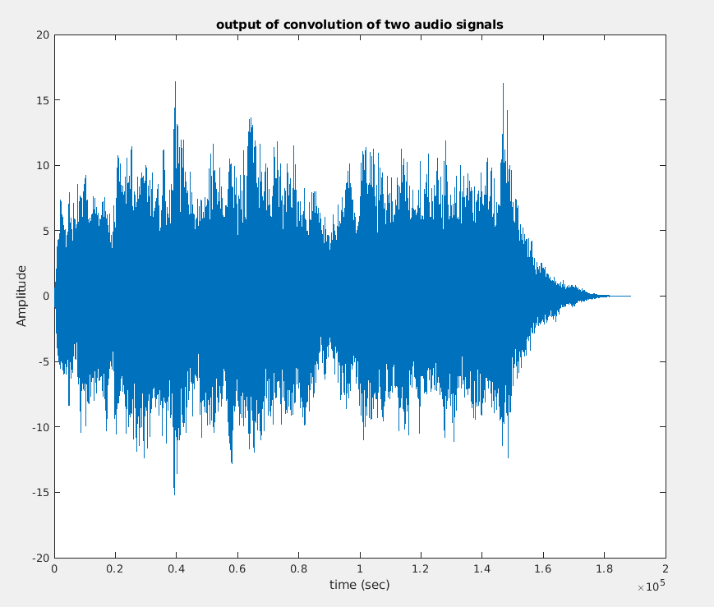

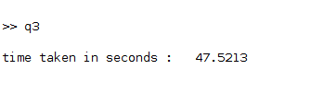

* We can see that by performing direct convolution of the two audio signals the time taken is 47.5213 seconds.

b)

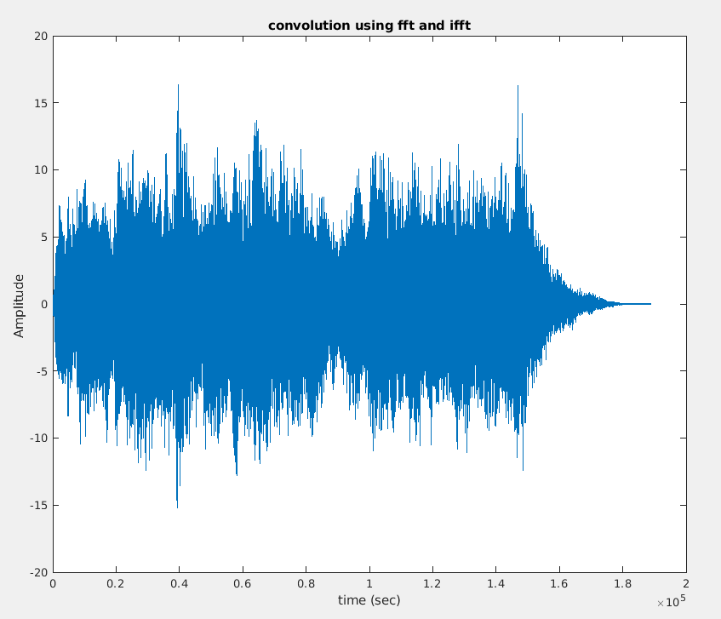

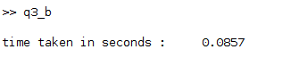

* We can see that the time taken to perform the convolution using fft and ifft is very less compared to direct convolution.
* This change in time is due to the fact that we need lot of computational power for finding the convolution, as it requires multiplication of so many data points, But in case of FFT and IFFT the computation is less due to the more effective FFT algorithm and less no.of multiplication in finding the FFT.

c)

**Overlap and add method**

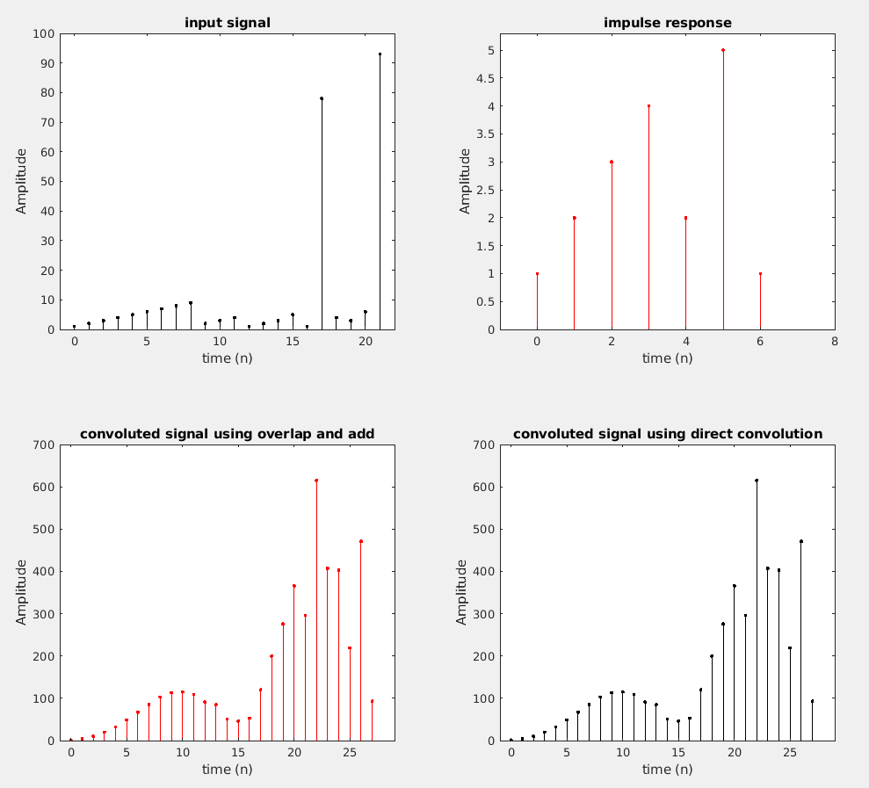

* In the plot given above the input signal, the impulse response and the convoluted signal by overlap and save and normal convolution is shown.
* The convolution by overlap and add is done by first breaking down the input signal to particular block sizes, then each of the block is convoluted with the impulse response, later all these convolutions are added in an overlapping manner so that we obtain the perfect convoluted output.
* Now we modify the code in such a way that the block convolution step is done by taking FFT and IFFT. The respective execution time is given below :





* The time taken for both FFT method and convolution method are almost comparable, this is because here the block size that we took is 7 and this is very small and there won’t be much notable difference between the convolution and FFT method.
* Here there are a total of 4 blocks therefore the time taken for each block is 0.000575 sec and 0.0006125 sec respectively for convolution and FFT method.
* Here there is not much difference between convolution and FFT approach because the block size is less, but when we take higher block sizes, especially for real time audio processing and other things like that, then the FFT approach will be more efficient and will have a far better execution time.
* Now we are going to take the given audio signals acoustic.wav and impulse_cathederal.wav as the input signals.
* The resulting graph, related execution time and the inferences are given below :

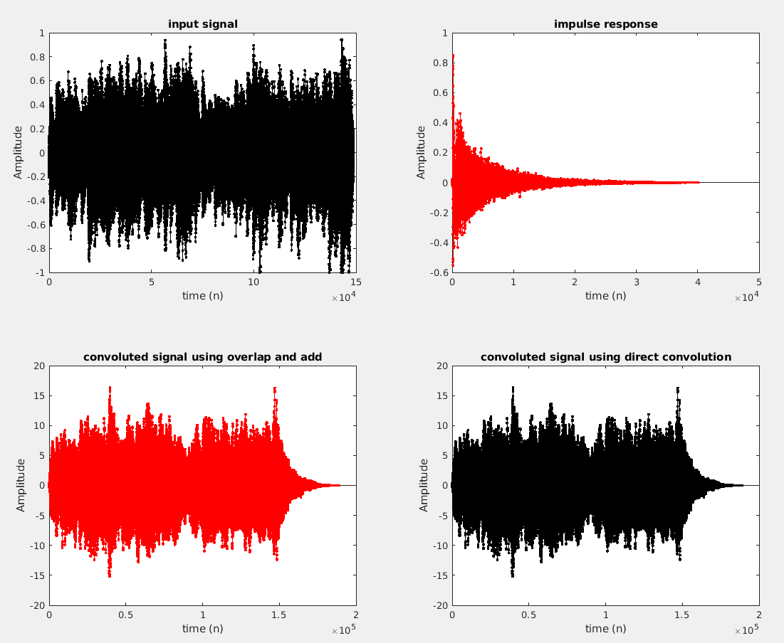





* Here we can see that the FFT method in overlap and save has worked faster than the normal convolution method, this is because here the block size that we took was larger, in fact it was equal to the length of the impulse signal.

**PART – B**

1. Write a MATLAB program to compute and display the poles and zeros of a transfer function. To do this, first compute and display the factored form of the transfer function. Then, generate the pole-zero plot of a transfer function, that is as a ratio of two polynomials in 𝑧−1. Using this program, analyze the z-transform of

$$H\left(z\right)=\frac{2+5z^{-1}+9z^{-2}+5z^{-3}+3z^{-4}}{5+45z^{-1}+2z^{-2}+1z^{-3}+1z^{-4}}$$

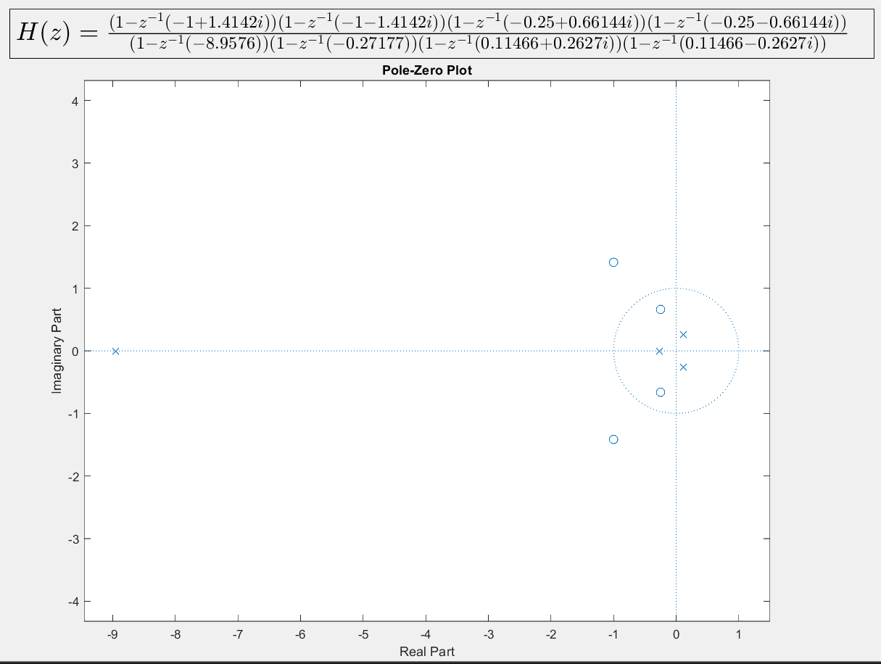

* Using the root() function on the Denominator and Numerator, the poles and zeros, respectively were obtained. Using these, the function was factorized and displayed on the figure using Latex.

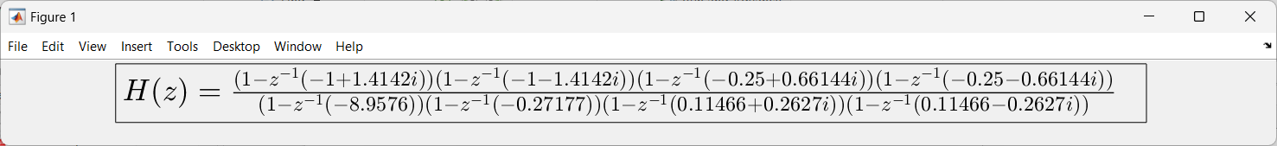

* The poles and zeros are given below

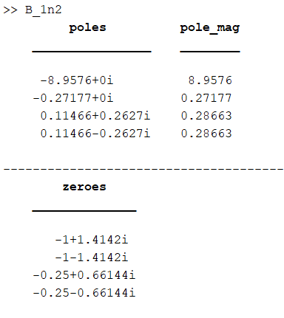

* Finally, they are plotted on the z-plane using zplane().

1. From the pole-zero plot generated in Qn (1), determine the possible ROCs. Can you tell from the pole-zero plot whether or not the DTFT exists? Is the system stable if it is causal?

* The below illustration denotes the areas enclosed by each pole.

(Two poles lie very close to each other, so the plot has been zoomed in.)

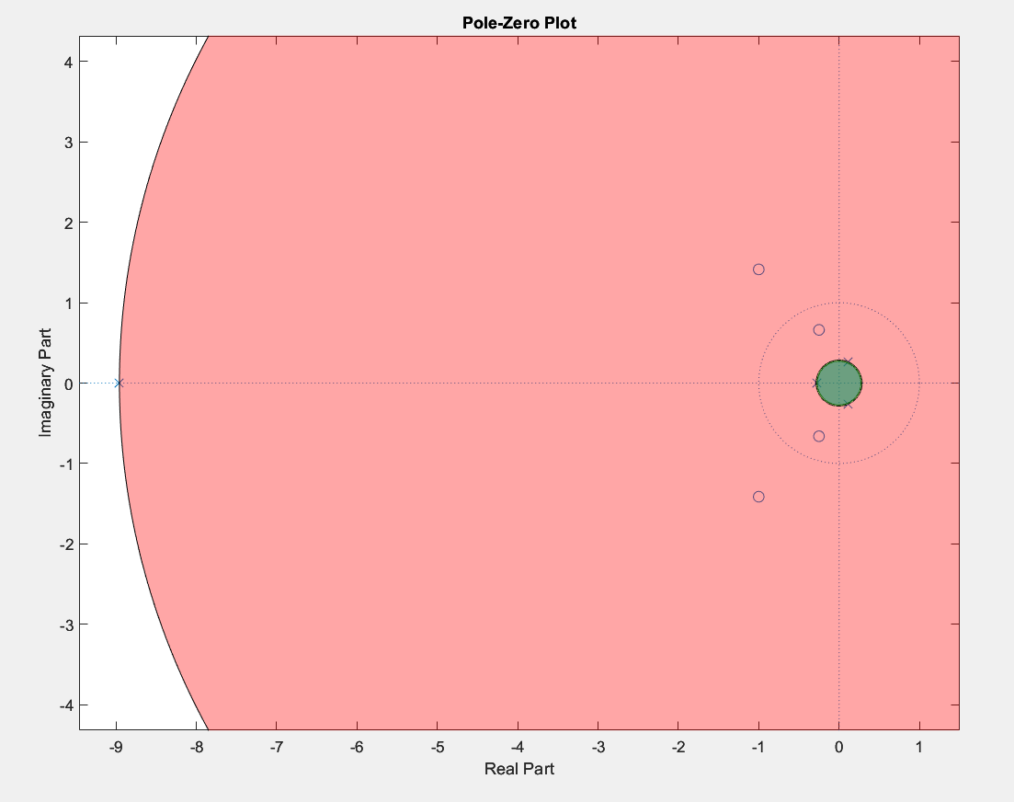

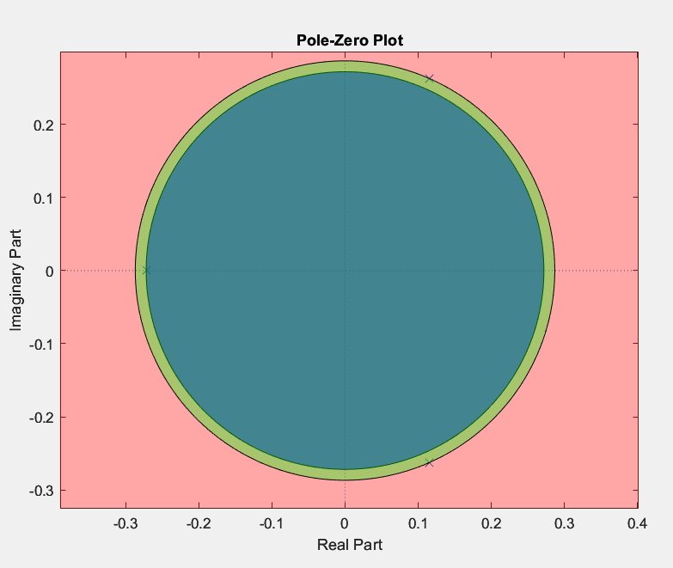

* Denote Red area as R, Green area as G, and Blue area as B
* The possible ROC’s for the given transfer function are -
  + Region I = B
  + Region II = (G - B)
  + Region III = (R – G)
  + Region IV = area outside R
* If Region III is chosen as the ROC then the unit circle is inside the ROC and the DTFT exists.
* A causal system has its ROC outside the outermost pole. This is represented by Region IV. This region doesn’t consist the unit circle, therefore such a system is unstable.

1. Using zp2tf, determine the rational form of a z transform whose zeros are at

𝑠1 = 0.3, 𝑠2 = 2.5, 𝑠3 = −0.2 + 𝑗0.4, and 𝑠4 = −0.2 − 𝑗0.4; the poles are at 𝑝1 = 0.5,

𝑝2 = −0.75, 𝑝3 = 0.6 + 𝑗 0.7, and 𝑝4 = 0.6 − 𝑗 0.7; and the gain constant 𝑘 = 3.9.

* The zeroes and poles of the given system are,
  + zero = [0.3 2.5 -0.2+1j*0.4 -0.2-1j*0.4]
  + pole = [0.5 -0.75 0.6+1j*0.7 0.6-1j*0.7]
* The output Numerator and denominator coefficients obtained from the zp2tf function is

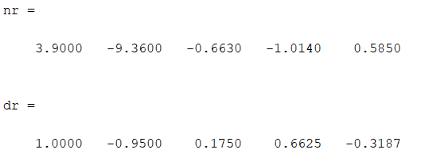

* 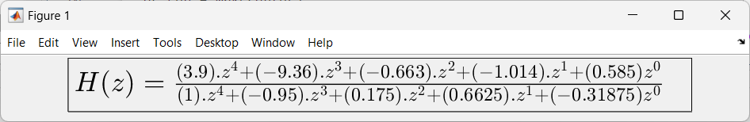The rational form of the function is

1. Using impz() determine the first 10 samples of the inverse Z transform of

$$H\left(z\right)=\frac{z^{-1}}{3-4z^{-1}+z^{-2}}$$

Using residuez obtain the partial fraction expansion of 𝐻(𝑧). From the partial fraction expansion, write down the closed form expression of the inverse Z transform (assuming causal). Evaluate the first 10 samples of the closed form expression for ℎ[𝑛] using Matlab and compare with the result obtained using impz.

* The poles, residues and gain of H(z) is obtained using residuez()

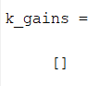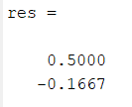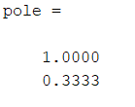

* The partial fraction representation of H(z) is given by,

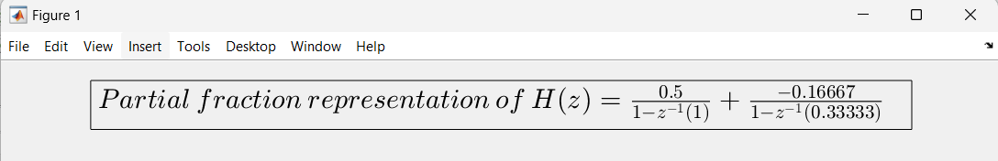

* Using the result $Z^{-1}\{\frac{1}{1-az^{-1}}\}=a^{n}.u\left(n\right)$, the closed loop expression of inverse of H(z) is,

$h\left(n\right)=0.5u\left(n\right)–0.5.{\left(0.33333\right)}^{n}.u\left(n\right)$

* The impulse responses have been plotted below.

Finally a comparison is done by plotting the impulse response of $H(z)$ using impz() and manually finding the impulse response by taking the convolution of $h(n)$ and the unit impulse. They are found out to be the same.

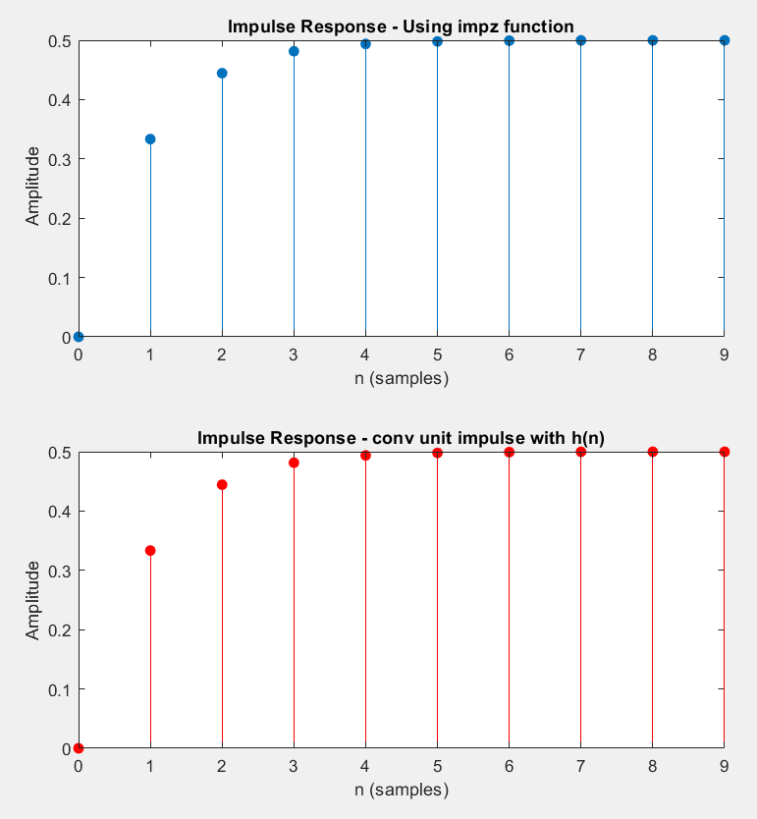

1. Using residuez() convert back the partial fraction expression for 𝐻(𝑧) in Part (4) to the rational function form.

* The reconstructed polynomial is

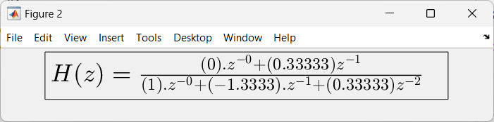

* Multiplying by 3 on the numerator and denominator, it is found that the reconstructed polynomial using residuez() is exactly the same.

1. Determine the zeros for the systems $H_{1}\left(z\right)=6+z^{-1}-z^{-2}$ and $H_{2}\left(z\right)=1-z^{-1}-6z^{-2}$, and indicate whether the system is minimum-phase, maximum-phase or mixed-phase system. Show responses.

* Zeroes can be calculated by taking the roots of denominator of the transfer function.
* 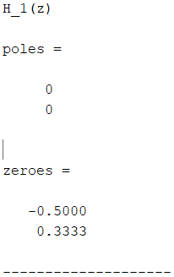For $H_{1}\left(z\right),$ 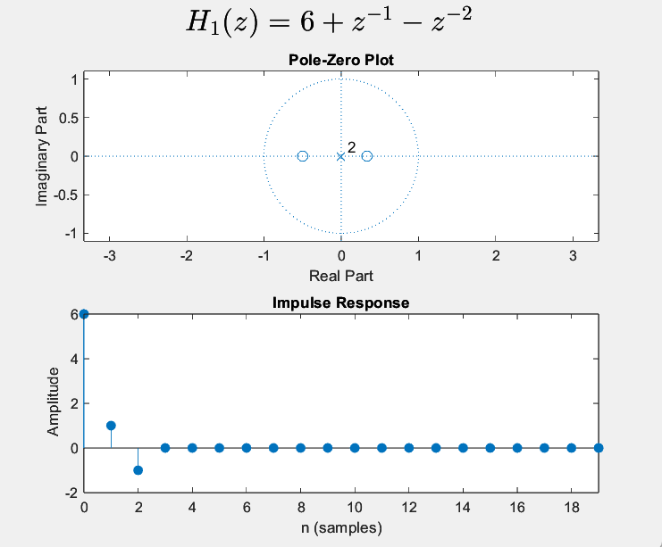the zeroes are observed to be inside the unit circle, hence it is a minimum phase system.
* For $H_{2}\left(z\right),$ the zeroes are outside the unit circle, hence it is a maximum phase system.

